Telnet

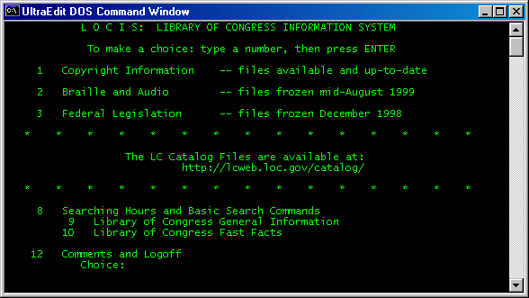

///////////////////////////////////////////////////
// Telnet-Client
// Telnet2.java

import java.net.*;
import java.io.*;

///////////////////////////////////////////////////

public class JTelnetC {

Socket sock;

public JTelnetC(String h, int p) {

try {

sock = new Socket(h, p);
new InputPipe(sock.getOutputStream()).start();
new OutputPipe(sock).start();

} catch(IOException e) {
System.out.println(e);
return;
}
}

//////////////////////////////////////////////

public static void main(String args[]) {
String host="locis.loc.gov";
//String host="fedworld.gov";
//String host="HAR1.HUJI.AC.IL";
//String host="nuk.uni-lj.si";
//String host="IX.URZ.UNI-HEIDELBERG.DE";
//String host="sun0.urz.uni-heidelberg.de";
//String host="opac.uni-tuebingen.de";
//String host="opac.server.uni-frankfurt.de";

int port = 23;
new JTelnetC(host, port);
}

///////////////////////////////////////////////////
// Horcher-Thread (Innere Klasse)

public class InputPipe extends Thread {

DataInputStream is;
PrintStream os;

public InputPipe(OutputStream os) {

this.is = new DataInputStream(System.in);
this.os = new PrintStream(os);
}

/////////////////////////////

public void run() {

String line;

try {

while(true) {

line = is.readLine();
os.print(line);
os.print("\r\n");
os.flush();
}
} catch(IOException e) {
throw new RuntimeException(e.getMessage());
}
}
}

/////////////////////////////////////////////////
// Schreib-Thread (Innere Klasse)

public class OutputPipe extends Thread {

InputStream in;
OutputStream ot;
PrintStream os;

public OutputPipe(Socket sock) {

try {
this.ot = sock.getOutputStream();
this.in = sock.getInputStream();
this.os = new PrintStream(System.out);
} catch(IOException e) {
System.out.println(e);
}
}
///////////////////////////////////////

public void run() {

int i;

try {
while(true) {
i = in.read();
if (i == 255) {
int i1 = in.read();
int i2 = in.read();
tel_net(i1,i2);
} else {
os.print((char)i);
os.flush();
}
}
} catch(IOException e) {
throw new RuntimeException(e.getMessage());
}
}
/////////////////////////////////////////

private void tel_net(int i1, int i2) {

int i = i1;

if (i == 253) {
i = i2;
if (i == 1) wont(i);
else if (i == 24) wont(i);
else if (i == 31) wont(i);
else if (i == 35) wont(i);
else if (i == 36) wont(i);
else if (i == 39) wont(i);
}
}

//////////////////////////////////////////
private void wont(int i){

try {
ot.write(255);
ot.write(252);
ot.write(i);
} catch (IOException e) {
System.out.println(e);
}
}
}
}

